**ASSIGNMENT-25.1:**

A table named Olympic is created and the data is loaded into the table. The columns of the Olympic table is described below :

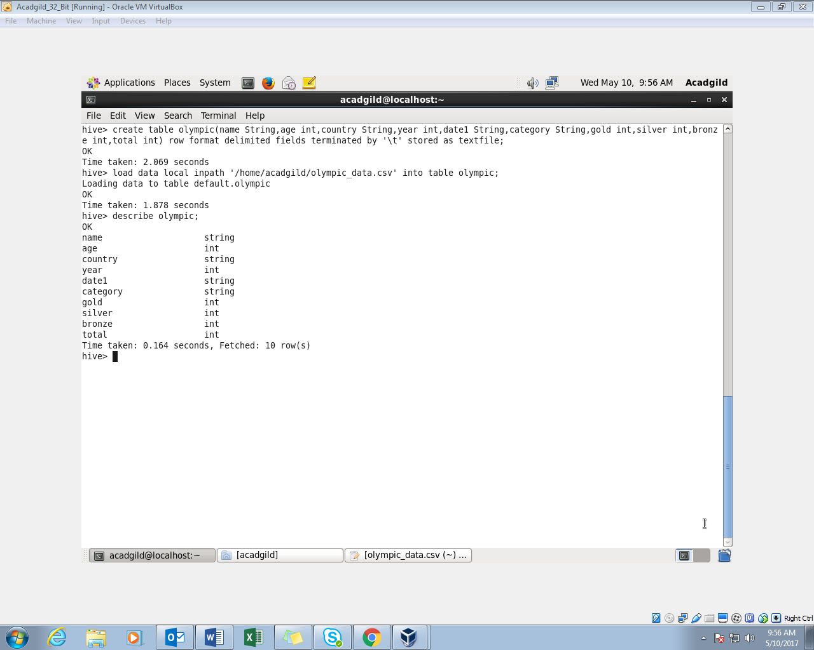

Question 1 : Write a Hive program to find the number of medals won by each country in swimming.

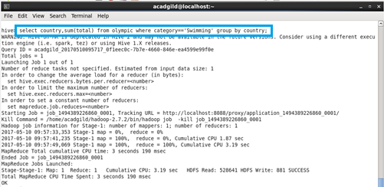

Output :

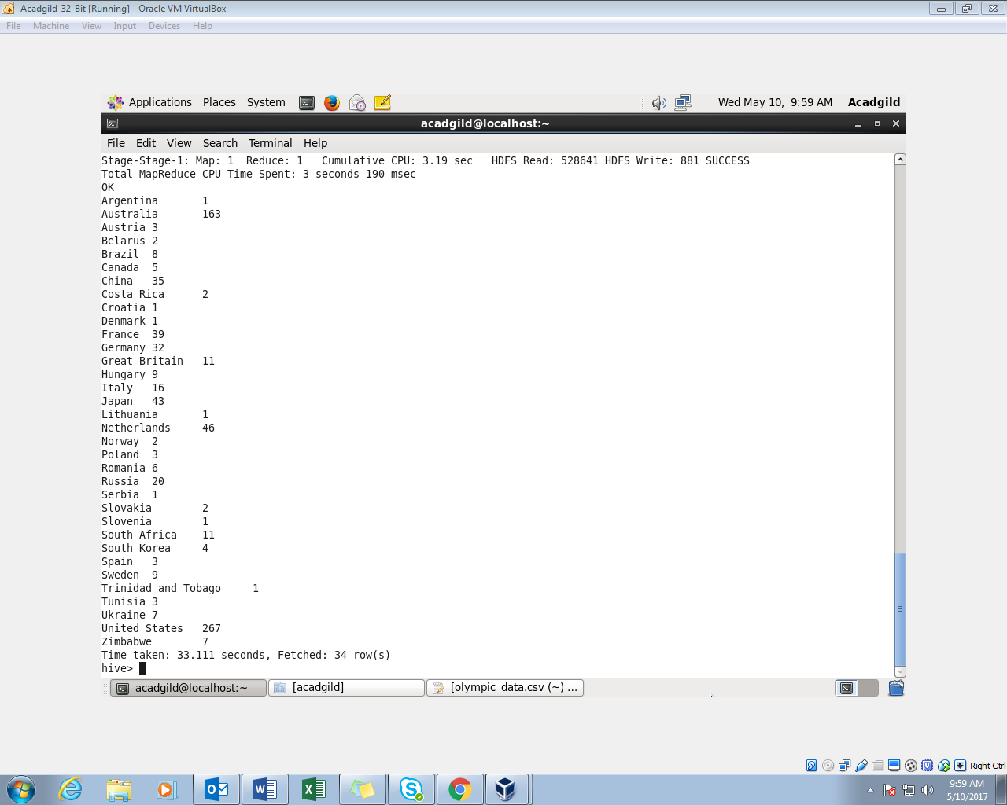

Question 2 : Write a Hive program to find the number of medals that India won year wise.

